שאלה 1:

Given a stack with a limit of k elements, where each k operations that is a copy operation that take O(I) where I is the number of elements in the stack.

Operation running time:

$$push=O\left(1\right)$$

$$pop=O\left(1\right)$$

$$copy_{i}=O\left(i\right)≤O\left(k\right)$$

Here we wrote the running time for each operation.

Let’s use amortize analysis to solve this.

Firstly, we need to understand that the copy running time is bounded by

$$O\left(k\right)$$

Because we are given a stack that can’t exceed k elements.

Copy operations

$$\left\lfloor \left.\frac{m}{k}\right\rfloor \right.$$

Running time analysis

$$E=\frac{\left[\sum_{i=0}^{i=\left\lfloor \left.\frac{m}{k}\right\rfloor \right.}{O\left(k\right)}+\sum_{i=0}^{i=m}{O\left(1\right)}\right]}{m}≤\frac{\left[\sum_{i=0}^{i=\frac{m}{k}}{O\left(k\right)}+\sum_{i=0}^{i=m}{O\left(1\right)}\right]}{m}$$

$$\frac{\left[\sum_{i=0}^{i=\frac{m}{k}}{O\left(k\right)}+\sum_{i=0}^{i=m}{O\left(1\right)}\right]}{m}=\frac{\left[\frac{m}{k}⋅O\left(k\right)+O\left(m\right)\right]}{m}$$

$$\frac{\left[\frac{m}{k}⋅O\left(k\right)+O\left(m\right)\right]}{m}=O\left(1\right)+O\left(1\right)=O(1)$$

שאלה 2:

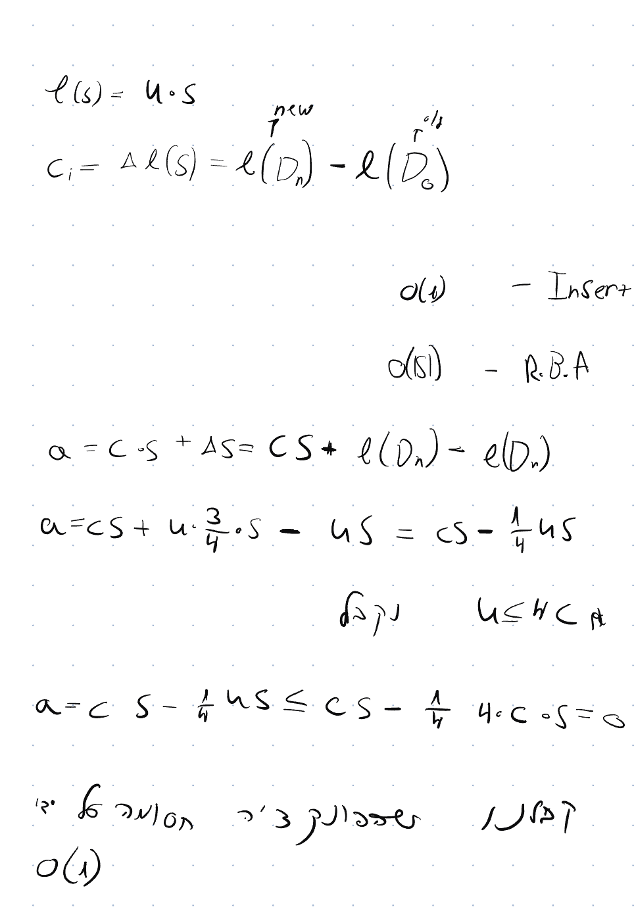

שאלה 3:

כאשר יש לנו עץ 2-3 הגובה יכול לנוע בין

$$\log_{3}{(n)}≤h≤\log_{2}{(n)}$$

ב:

להבנתי מדובר על פעולה של search, אפשר לבצע פעולה זו בצורה יחסית מהירה

$$O\left(\log_{2}\left(n\right)\right)$$

על ידי האלגוריתם הבא

ג:

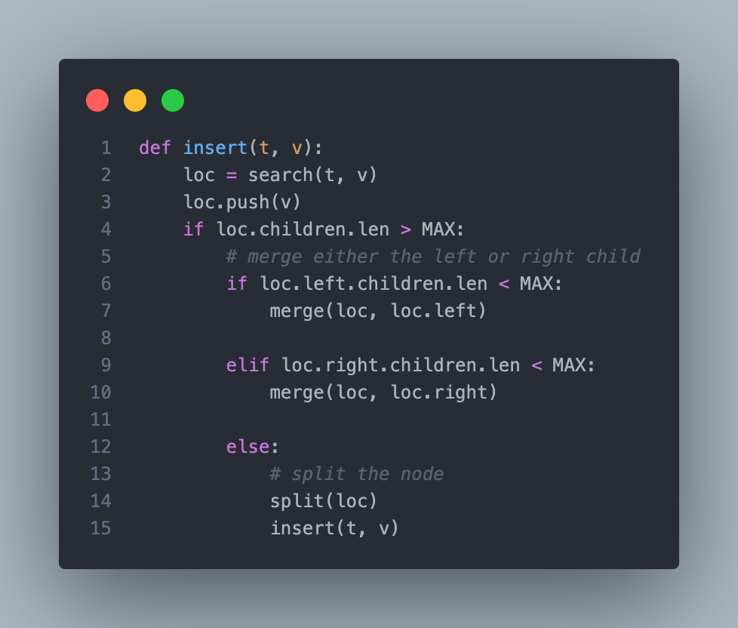

שאלה 4:

We will describe the following algorithm:

First, we will assert W.L.O.G that h1 > h2 and T1 >T2 the algorithm will be very similar for T2<T1.

We will move h2 steps on T1, so we get loc = T1.moveleft(h2) == O(h2)

We will append T2 root to loc == O(1)

If loc.count == 4: O(1)

CreateNewParent(loc) == O(h1)

Else if loc.count == 3: O(1)

FixErrorFrom(loc) == O(h1)

DONE

Function CreateNewParent(loc): O(H)

P = Take the loc[2] and split the items

P.parent.push(P)

If P.silblings.len > MAX:

FixErrorFrom(P)

Return P

Function FixErrorFrom(loc): O(H)

P = Take the middle child and push it to the parent

If P.siblings > MAX:

FixErrorFrom(Loc)